The Effect of Income on Residential Energy Consumption

by

Lukas Diex

September 27, 2024

1. Introduction

**Contents**

Residential energy consumption & Housing sector emissions

1. Data

Residential Energy Consumption Survey, 2020

1. Multi‑level Modeling

Accounting for clustered data structure

1. Energy Consumption

Differentiation between types of energy usage

1. Results

Climate zone specific random intercepts Fixed effects for income across climate zones

Introduction 1/26

**Introduction**

1. 20% of US energy consumption

**Housing ‑ Consumption & Emissions**

1. 18% of total US energy‑related CO2‑emissions
2. Energy transition as a prerequisite for meeting Paris 2050 targets
3. But what acutally determines energy consumption in the housing sector?

**What is the effect of household income on residential energy consumption?**

Introduction 2/26

Data 3/26

**Data**

First conducted in 1978

**RECS 2020**

Facilitated by the *U.S. Energy Information Administration*

2020 wave of the Residential Energy Consumption Survey

**Environmental conditions**

**Technical characteristics of the housing stock Household demographics**

Additionally, from the *Federal Reserve Bank of St. Louis*:

**Per capita personal income by state, 2020**

Data 4/26

Multi‑level Modeling 5/26

**Multi‑level Modeling**

Modelling approach following *Tso and Guan (**2014**) and Belaïd et al. (**2019**)*

**Multi‑level Modeling ‑ I**

Splits total variation in energy consumption into area variation and household variation

Quantifies clustering extent of REC among areas and examines cross effects of area‑level and household‑level factors

Zone 1

Zone 2

Zone 3

|  |  |  |
| --- | --- | --- |
| Obs. 1 | Obs. 2 | Obs. 3 |

|  |  |  |
| --- | --- | --- |
| Obs. 4 | Obs. 5 | Obs. 6 |

|  |  |  |
| --- | --- | --- |
| Obs. 7 | Obs. 8 | Obs. 9 |

Multi‑level Modeling 6/26

**IECC Climate Zones (ICC,** **2013****)**

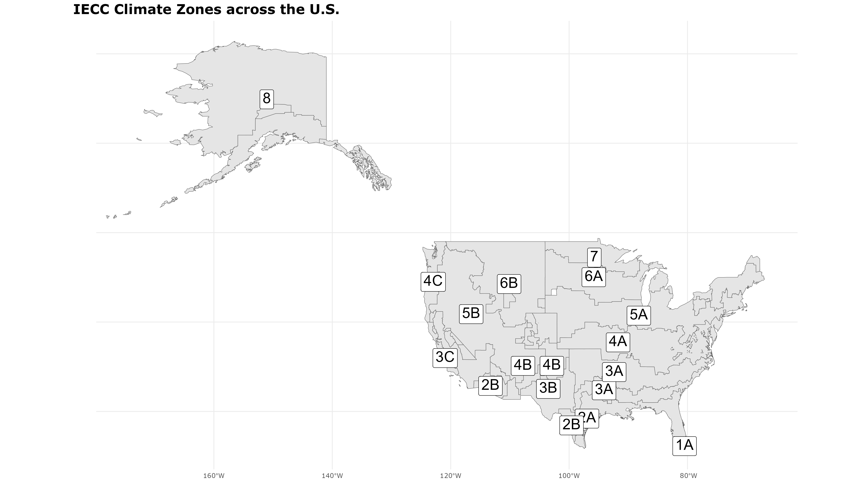Multi‑level Modeling 7/26

**The Null‑model**:

**Multi‑level Modeling ‑ II**

*yij* = β00 + *u*0*j* + *eij* (1)

How much of total REC variation can be explained by area‑level variation?

σ2

*ICC* = 2 *u* 2

(2)

σ*u* + σ*e*

*uj* ∼ *N*(0, σ2), *eij* ∼ *N*(0, σ2) (3)

*u e*

ICC for HAC‑model: 30.3% ICC for Non‑HAC‑model: 0.9%

Multi‑level Modeling 8/26

**The Full‑model**

**Multi‑level Modeling ‑ III**

*Yij* = β00 + ∑ β*k*0 *· Xkij* + ∑ β0*q · Zlj* + ∑ *ukj · Xkij* + *u*0*j* + *eij* (4)

*k l k*

β00 = Grand mean intercept across all climate zones

∑*k* β*k*0 *· Xkij* = Fixed effects of independent variables

∑*l* β0*q · Zlj* = Cross‑level interaction effect of per capita personal income

∑

*k ukj · Xkij* = Random slope effects of per unit costs for energy and per capita personal income

*u*0*j* = Random intercept effects for respective climate zones

*eij* = Error term

Variable selection following an **Adaptive Elastic Net Selection process**

Multi‑level Modeling 9/26

Energy Consumption 10/26

**Energy Consumption**

**Energy End‑use Definition**

**HAC Energy Consumption**:

Energy used for Heating and Air Conditioning

**Non‑HAC Energy Consumption**:

Energy used for all purposes other than HAC, e.g. lighting, EVs, Refrigerators

Energy Consumption 11/26

**Distribution of Energy Consumption**

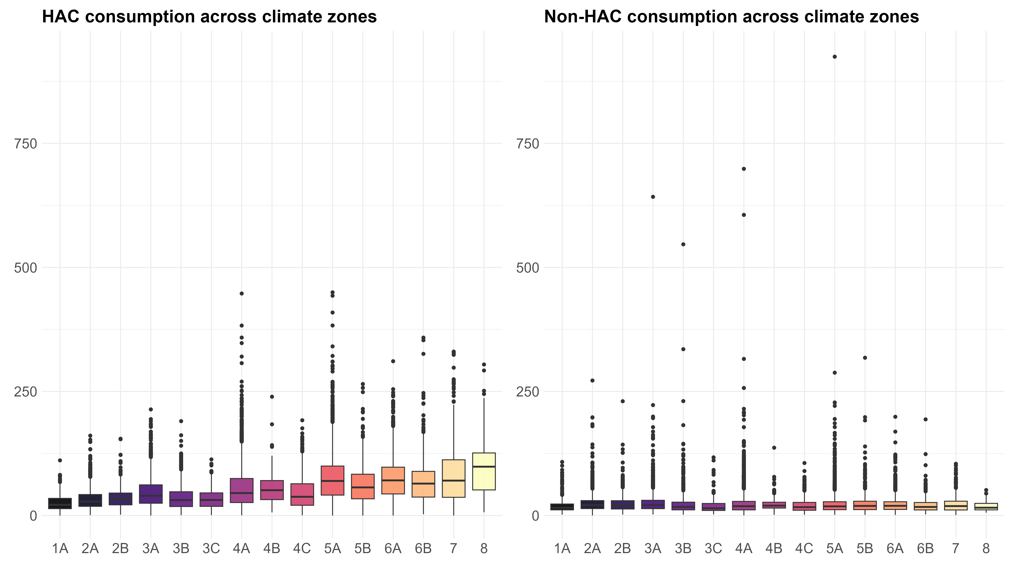

Energy Consumption 12/26

Results 13/26

**Results**

# Variation between Climate Zones

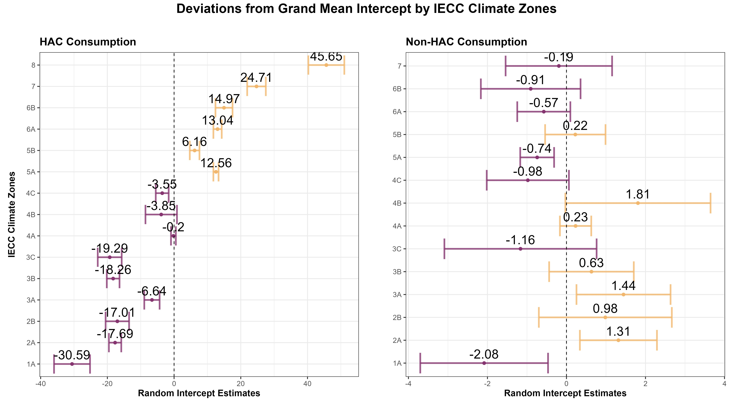

Results 14/26

# Fixed Effect of Income

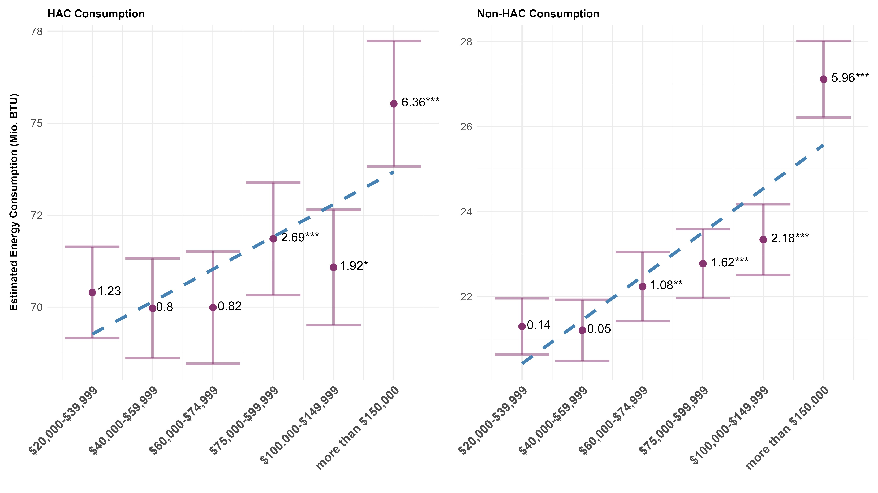

Results 15/26

Housing unit characteristics

**Controls**

**Single‑family detached houses** consume 3% less HAC

**Apartment building with 5 untis or more** consume 25% less HAC The younger the year of construction, the lesser energy is consumed Space and water heating fuels are highly significant

Other Sociodemographics

Households achieve **economies of scale**

Life‑cycle: HAC consumption increases especially for older ages Non‑HAC consumption decreases with age

Microclimate HDDs and CDDs **increase HAC consumption**

Results 16/26

Conclusions 17/26

**Conclusions**

Overall, increases in income increase residential energy consumption However, **no quadratic relationship between income and energy**

**Closing Thoughts**

Substantial **variation between climate zones** for HAC consumption HAC consumption: technical characteristics of the housing stock Non‑HAC consumption: Households’ sociodemographics

Conclusions 18/26

Conclusions

19/26

**References**

Belaïd, Fateh, David Roubaud, and Emilios Galariotis (2019). “Features of residential energy consumption: Evidence from France using an innovative multilevel modelling approach.” In: *Energy* *policy* 125, pp. 277–285.



ICC (2013). *2012 International Energy Conservation Code (IECC)*. Retrieved June 17, 2024, from



<https://codes.iccsafe.org/content/IECC2012>. International Code Council.

Tso, Geoffrey KF and Jingjing Guan (2014). “A multilevel regression approach to understand effects of environment indicators and household features on residential energy consumption.” In: *Energy* 66,



pp. 722–731.

Conclusions 20/26

Appendix 21/26

**Appendix**

# Distribution of REC for Climate Zones

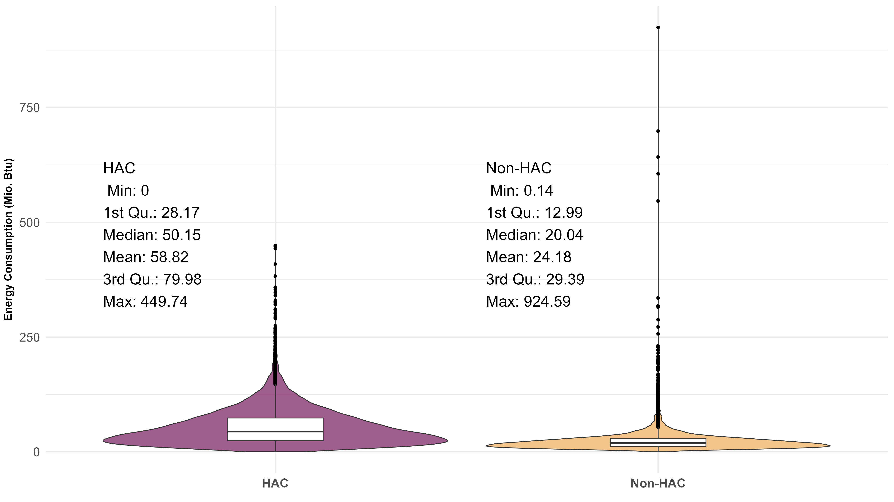

Appendix 22/26

Removing outliers outside the 6‑sigma range Recentering and standardizing continuous x‑variables

**Data Manipulations**

Grand mean of the sample for group‑level

Group‑average for household‑level Rescaling sampling weights

Eq. 5 reduces observation’s weights proportionally to how much the

cluster structure inflates the variance

The ”effective” sum of weights then refers to the number of independent observations that the clustered data effectively represent: **14,623.15**.

∗ *ij* ( ∑*i wij* )

*wij* = *w* ∑ *w*2

*i*

*ij*

(5)

Appendix 23/26

β^AdaEnetR =

(1 + λ2

arg min

)

β

*Ln*(β) + λ2



**Adaptive Elastic Net Selection Process**

∑

*j*=1

*p*

β2 + λ1

∑

*j*=1

*p*



ω^ *j*|β*j*|





(6)

*Ln*(β) = Loss function, measuring the fit of the model based on the residuals

*j*

λ1 ∑

*n*

*p j*=1 *p j*=1

λ2 ∑

ω^ *j*|β*j*| = Adaptive Lasso penalty, shrinks coefficients to zero

β2 = Ridge penalty, shrinks remaining coefficients towards zero

*j*

1 + λ2 = Scaling term, adjust the contribution of the Ridge‑regularization term relative to the size of the dataset

*n*

**Elastic**: 10‑fold cross‑validation process with a sequence of α‑parameters from 0 (Ridge) to 1 (Lasso) is estimated in order to balance the two penalties.

Appendix 24/26

# Random Slope Effects (HAC)

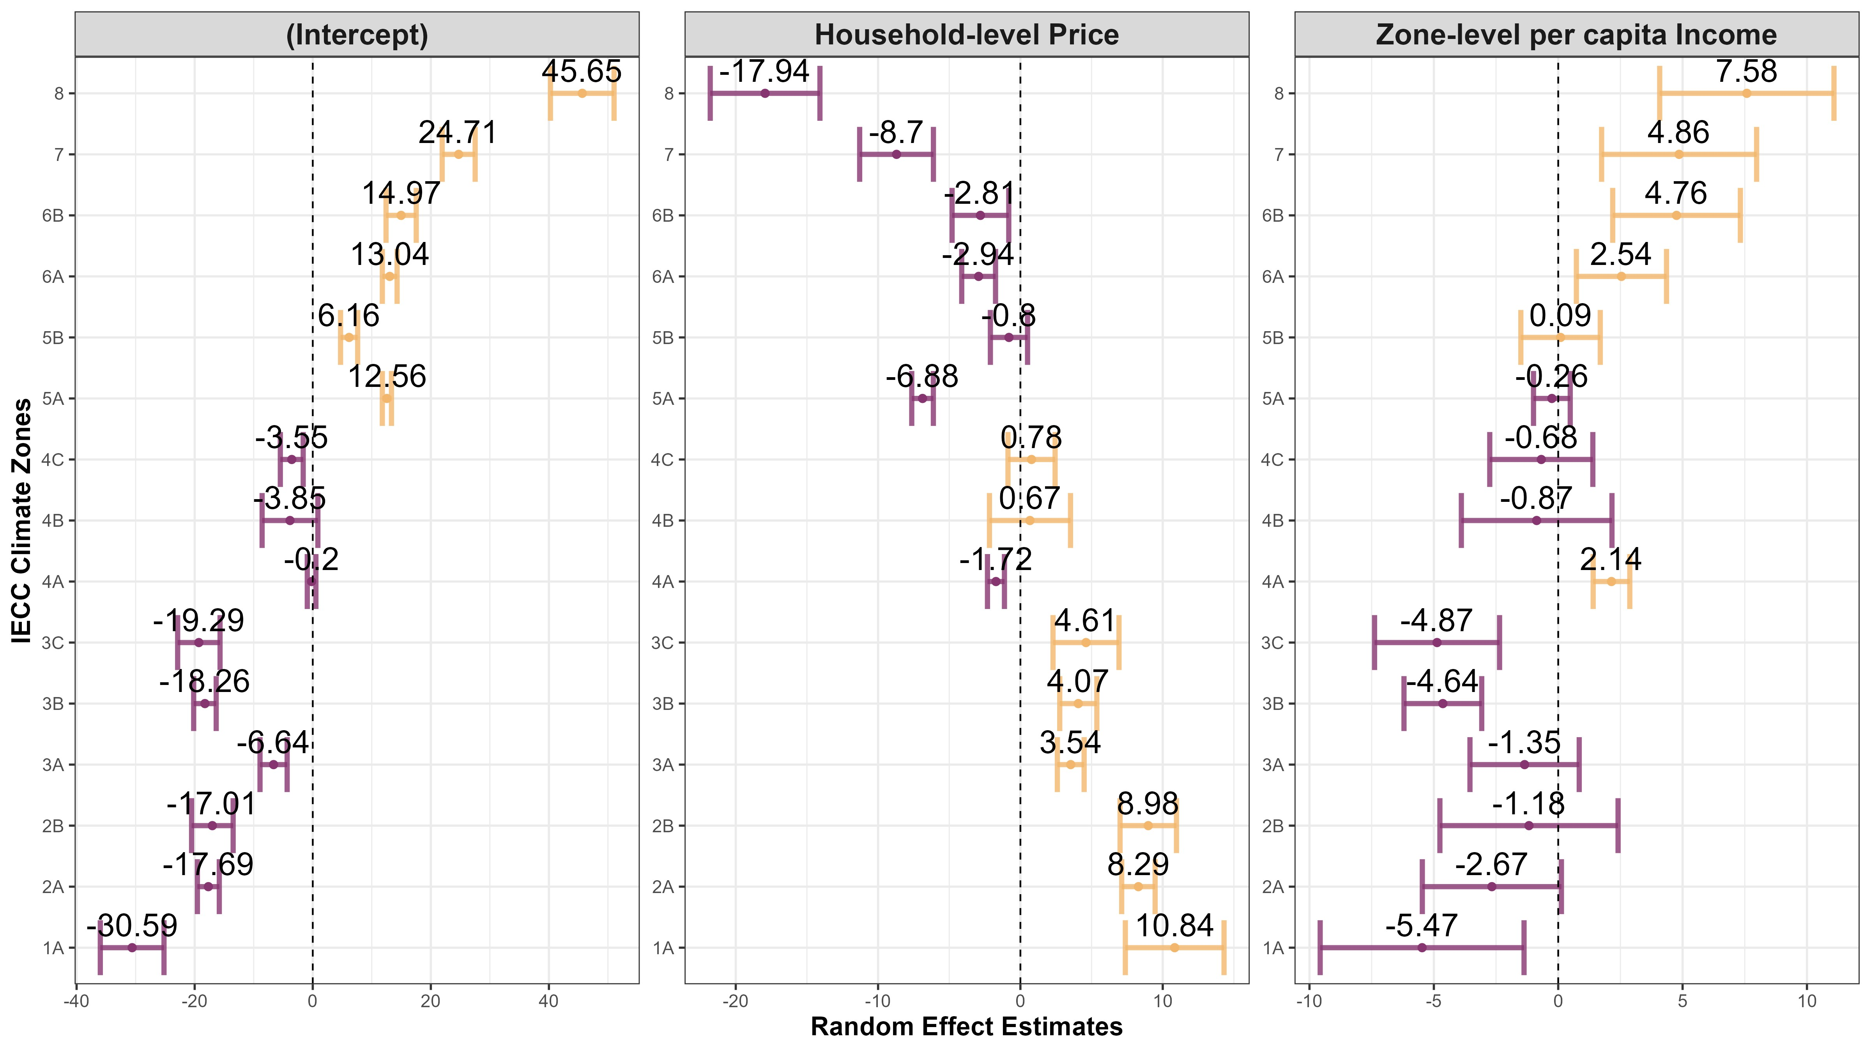

Appendix 25/26

# Random Slope Effects (Non‑HAC)

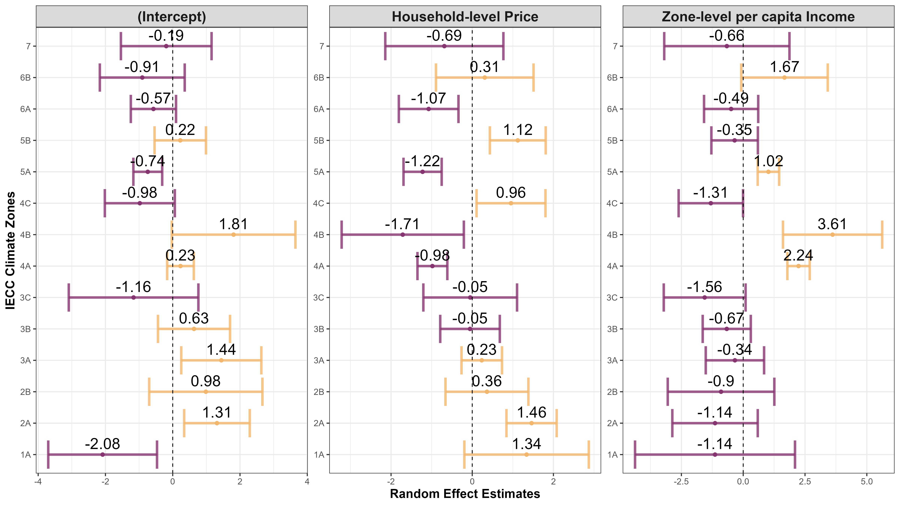

Appendix 26/26